Online Appendix supplementing "A Tutorial in Bayesian Potential Outcomes Mediation Analysis”
The paper demonstrates the calculation of causal indirect and direct effects in four different software packages: WinBUGS using the R2WinBUGS R package, JAGS through the blavaan R package, the MCMC procedure in SAS, and Mplus.
Certain details of setting up the analysis in R were omitted from the paper due to space considerations, however, we created this online appendix for users that are new to R, WinBUGS, and JAGS. This appendix provides details about what freeware you need to download and install, and how to activate the necessary packages before running the analysis.
1. WinBUGS using the R2WinBUGS R package
For this analysis, you will first need to download WinBUGS and R. Note that WinBUGS is designed for a Windows platform, thus if you still wish to use freeware but do not have a Windows system, use the option of running the analysis in JAGS through the blavaan R package.
WinBUGS can be downloaded from the website:
https://www.mrc-bsu.cam.ac.uk/software/bugs/the-bugs-project-winbugs/
To download R, go to: https://www.r-project.org/
After you have installed both WinBUGS and R on your machine, you need to install the package R2WinBUGS. You will do this by opening R, and typing the following syntax in the R Console, and pressing Enter:
install.packages(“R2WinBUGS”)
This is what the console should look like with your syntax typed in, right before you press Enter:
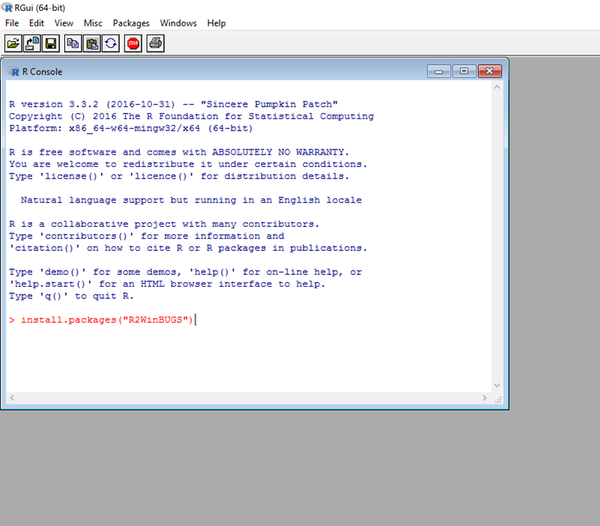
After the package has been installed, you will need to activate it in order to use it for your analysis. This is done with the following line of syntax, also typed into the R Console:
library(R2WinBUGS)
This is what your console should look like after you have installed the R2WinBUGS package, and after you have typed the syntax to activate the package:
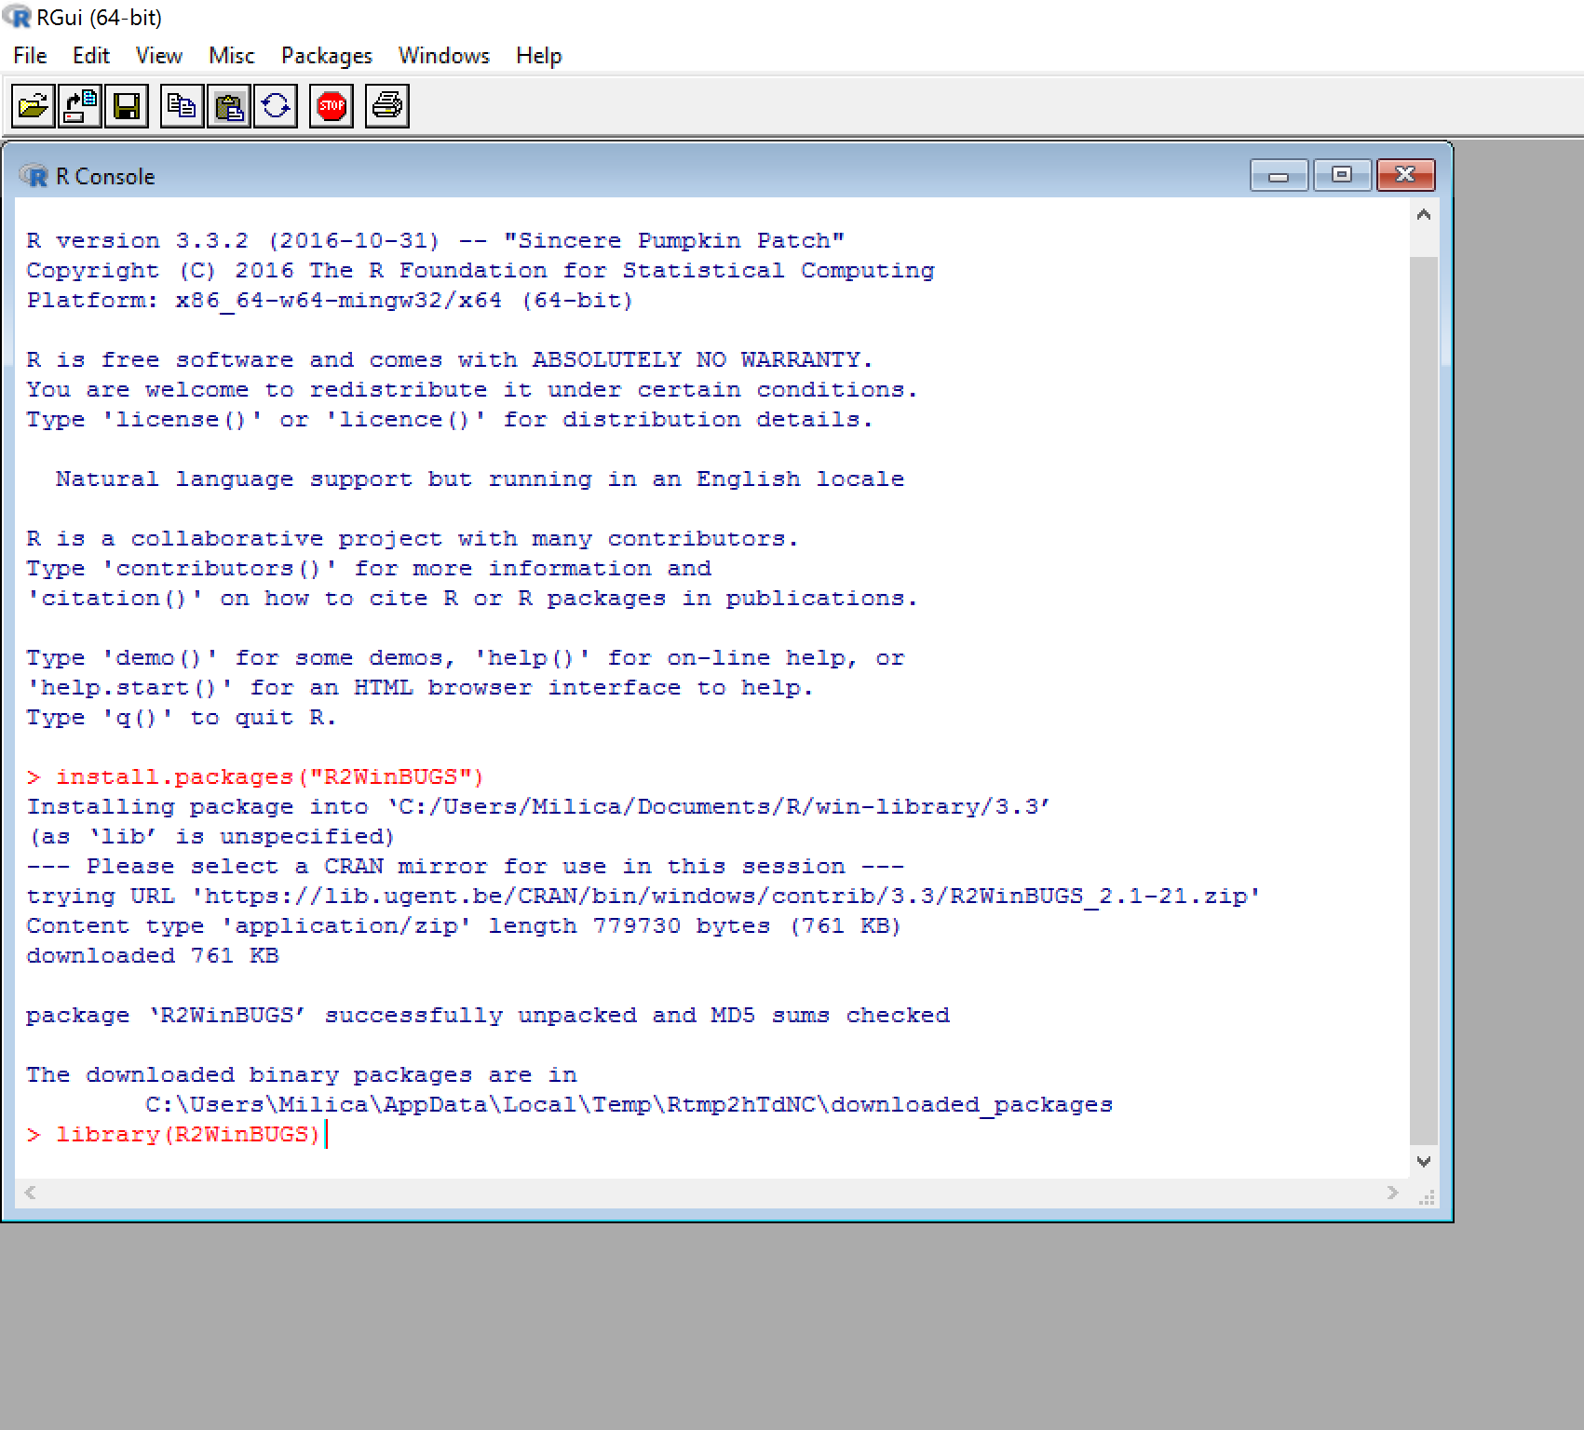
All you need to do after this line of syntax is click Enter, and the package R2WinBUGS will be ready to use.
If you will be using the coda package to further examine the convergence of the chains (as described in the paper), you will need to download and activate coda as well.
install.packages(“coda”)
library(coda)
2. JAGS using the blavaan R package
For this analysis, you will first need to download JAGS and R. Note that JAGS can be used both on Windows and Mac platforms.
JAGS can be downloaded from the website: http://mcmc-jags.sourceforge.net/
To download R, go to: https://www.r-project.org/
After you have installed both JAGS and R on your machine, you need to install the package blavaan. You will do this by opening R, and typing the following syntax in the R Console:
install.packages(“blavaan”)
After the package has been installed, you will need to activate it in order to use it for your analysis. This is done with the following line of syntax, also typed into the R Console:
library(blavaan)
If you will be using the coda package to further examine the convergence of the chains (as described in the paper), you will need to download and activate coda as well.
install.packages(“coda”)
library(coda)

